

**Business Evaluation**

|  |  |  |
| --- | --- | --- |
| **Family-owned business** | **Values** | **Immediate Goals** |
| 500 dealers, service centers in 100 countries.  20% yearly growth | Excellent customer service Minimize vehicle downtime | ● Provide best-in-class online fleet management services to our customers ● Improve operations of our dealerships and enable access to data  ● Predict and detect vehicle malfunction |

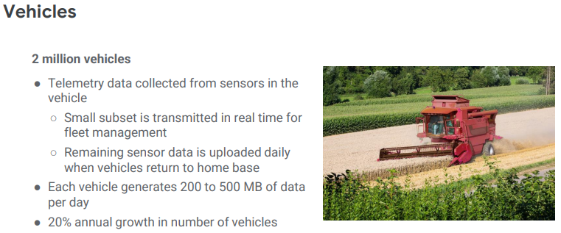

**Key business assumptions**

|  |  |  |
| --- | --- | --- |
| **Predict/detect vehicle malfunction and rapidly ship parts for just-in-time repair** | **Create a platform for developers to create services for dealers and partners - without compromising security** | **Decrease cloud operational costs; Increase speed and reliability of development** |

**Technical Evaluation**

|  |  |  |
| --- | --- | --- |
| **Existing Environment** | **Technical Watch points** | **Proposed Solution** |
| ● Multiple systems run in Google Cloud; some legacy systems still  ● Web frontend for dealers and customers is in Google Cloud and allows access to stock management and analytics | Applications  ● Container-based workloads  ● Highly scalable  ● Cloud-native solutions for keys and secrets management  ● Identity-based access | • Google Kubernetes Engine for managed containers  • Secret Manager  • Identity-Aware Proxy |
| Vehicles  ● 2 million vehicles x 200 to 500 MB/day | Migration and Partner Access  ● Create abstraction layer for HTTP API | Device management  • IOT Core Messaging  • Pub/Sub |
| Manufacturing  ● Sensor data is captured from two plants and sent to private data centers  ○ legacy inventory and logistics systems  ○ Private data centers have network interconnects to Google Cloud | Development  ● Modernize CI/CD pipelines  ● Create self-service portal for project and resource management  ● Manage API endpoints | • Cloud Build CI/CD  • VM running the Cloud Bolt software  • Cloud Endpoints |